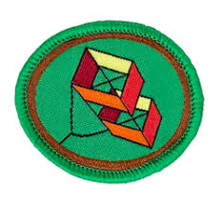
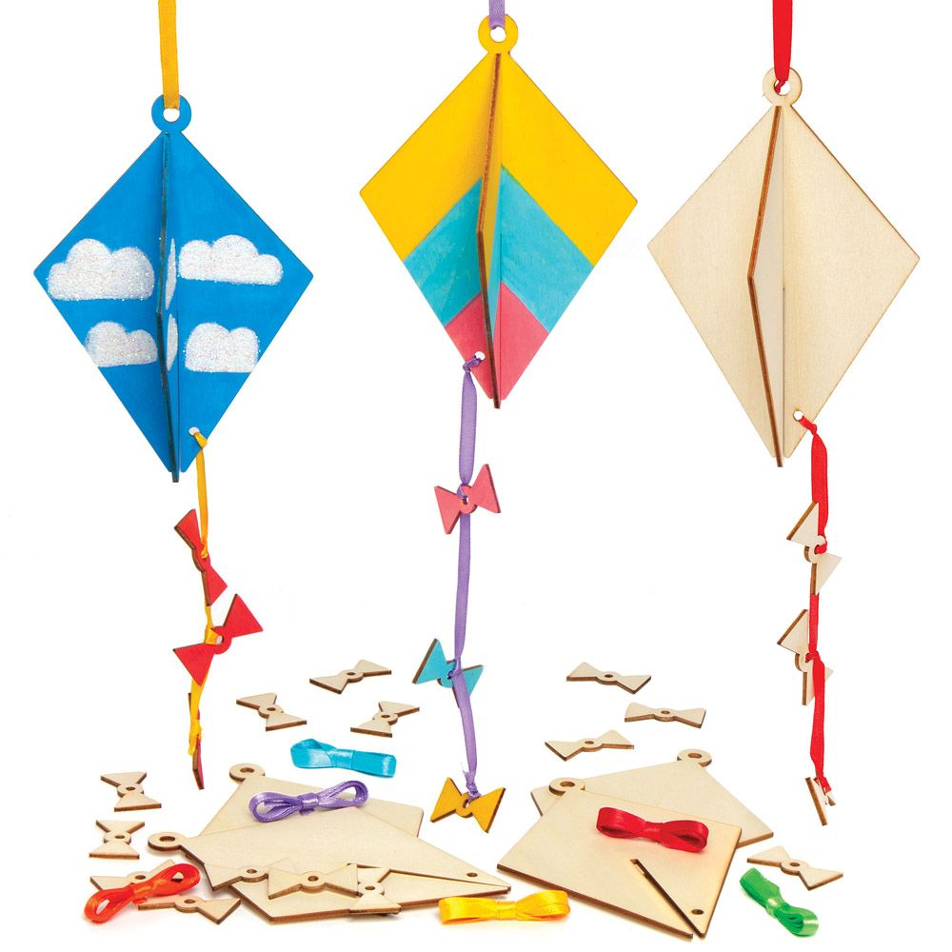
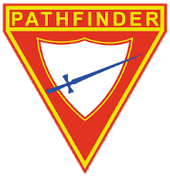
1.Kites Honour

When were kites first made and flown?

__________________________________________________________
__________________________________________________________
Name at least three ways kites have helped in scientific research and
tell how each has affected the world we live in.
Ways Helped Affect
1. ___________________________ ____________________________
2. ___________________________ ____________________________
3. ___________________________ ____________________________

Tell the story of Benjamin Franklin and his kite. __________________________________________________________ __________________________________________________________ __________________________________________________________ __________________________________________________________ __________________________________________________________ __________________________________________________________

Name some of the ways that kites might be used today. __________________________________________________________ __________________________________________________________ __________________________________________________________

Explainbrieflyhowkitesfly.
__________________________________________________________ __________________________________________________________ __________________________________________________________
Recreation General Conference 2002 Edition

J 4.
Define the following terms:
Spine _____________________________________________________
Spar ______________________________________________________
Vent ______________________________________________________
Bowstring __________________________________________________
Cover _____________________________________________________
Frame _____________________________________________________
Tail ______________________________________________________
Keel ______________________________________________________
Flying line _________________________________________________
Bridle _____________________________________________________
Reel ______________________________________________________

J 5 What is a common cause of kite failure? __________________________
___________________________________________________________

J 6. What should be done when a kite loops during flight? ___________________________________________________________

J 7. Why is a tail sometimes needed on a kite? _________________________ ___________________________________________________________

J 8. Know at least three safety rules for kite flying.

1. ________________________________________________________
2. _______________________________________________________
3. _______________________________________________________

J 9 Do the following:

a. Correctly wind line on a stick.
b. Tie broken ends with the fisherman's knot.

J 10 Make and successfully fly two of the following kites:

a. Sled kite
b. Flat kite
c. Two-stick diamond kite
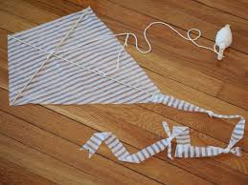
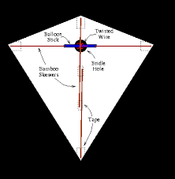

d. Delta wing kite

https://m.youtube.com/watch?v=BzB6dU39XcU

https://www.my-best-kite.com/how-to-build-a-delta-kite-mk2.html

e. Eddy or Malay kite f. Box kite
g. Tetrahedral kite

Date completed ____________ Instructor’s Signature ____________________

Spiritual Object Lesson from kites: John 16: 12-15

KITE FUN:
5 Christian aspects of a kite - concentrating on the Holy Spirt
1) The cross shape dowels are how you begin to build a kite and the CROSS is the beginning of the Christian life;
2) a kite needs a tail to keep the kite stable in the wind and Christians have the Word of God, to keep them stable;
3) a kite needs covering to catch the wind - Jesus covers all our sin and debt
; 4) a kite has to be anchored to something that won't blow away and we, as Christians have Jesus Christ as our anchor; and
5) kites need the wind to fly. The HOLY SPIRIT is our helper to lift us up.

https://sermons4kids.com/unseen_power_group_activities.htm

Resources

Materials for Making a Kite
- A plastic sheet e.g any light weight plastic bag, dry clean plastic bag.
- Bamboo sticks or any strong light weight sticks.
- Scissors.
- Pencil.
- String.
- Masking tape or packing tape.
- Ruler (if you want to be accurate with measurements)
- Ribbons for decorating (optional).

