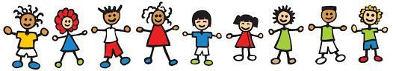
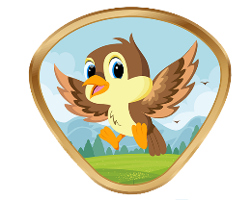
COMMUNITY FRIENDS

NAME:………………………………………………………………………………………………
DATE COMPLETED:………………………………………………………………………….

- Name five (5) different friends who live in your community.

1 2 3

4 5

Make a scrapbook or collage of your neighborhood friends, including at least five (5) different people.

Tell three (3) things that you and your friends can do to make your neighborhood a better place.

1 2 3
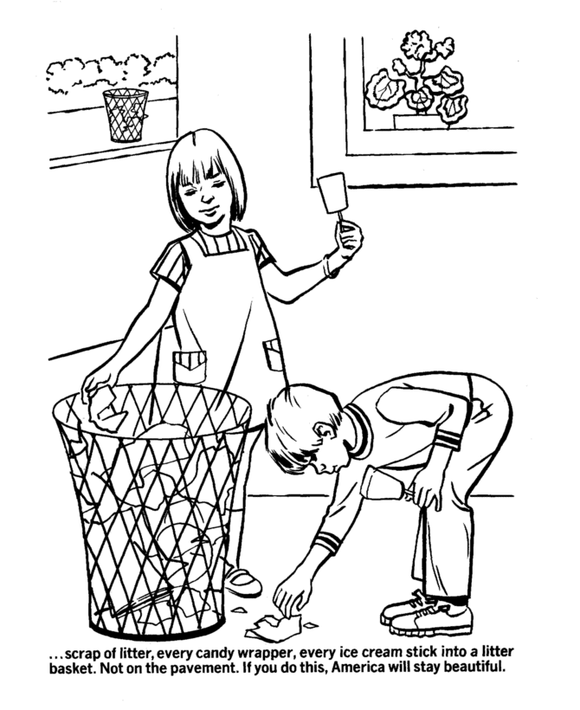
………………………………………………………………………………………………………………………………………………………………………………

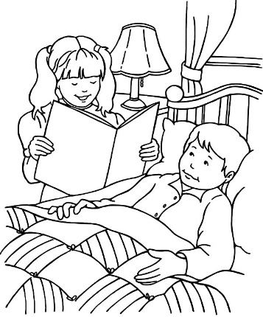
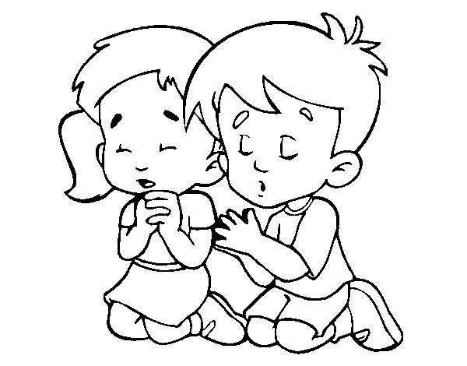
To keep the community clean
welcome to new neighbours
to our community

To visit those who are sick in the community
Pray for our community

Tell one of your friends that Jesus loves them.(when you do color the smile face)

Do something nice for a community friend.

Make a new friend in your neigborhood

- Name of your new friend…………………………………………………………………………….

- Where is he/she from?.........................................................................................

- How old is your new friend?.............................................................................

- What did you do together?……………………………………………………………………………

- If you like glue a picture of you and your new friend.

