Adventist Pioneers

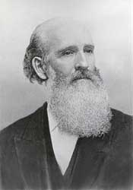
James White
- James White’s full name, including his middle name

………………………………………………………………………………………………

- What was the name of James White’s famous wife?

………........................................................................

- James White’s date and place of birth

………………………………………………………………………………………………………………..

- Which periodical (magazine) did James White start in 1849?

…………………………………………………………………………………..

- What is the current name of that periodical?

…………………………………………………………………………………………….

- What medical condition prevented James White from obtaining a formal education early in his life?

………………………………………………………………………………….

Outline 3 other facts about James White
Fact 1
……………………………………………………………………………………………………………………..
……………………………………………………………………………………………………………………..
……………………………………………………………………………………………………………………..

Fact 2
……………………………………………………………………………………………………………………..
……………………………………………………………………………………………………………………..
……………………………………………………………………………………………………………………..

Fact 3
……………………………………………………………………………………………………………………..
……………………………………………………………………………………………………………………..
……………………………………………………………………………………………………………………..

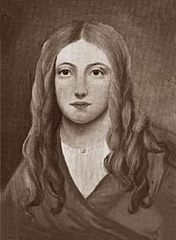
Annie R Smith
At what age did Annie Smith accept Jesus Christ as her Saviour? ………………………

Outline Annie’s contribution to Adventist publishing
………………………………………………………………………………………………………………………….
………………………………………………………………………………………………………………………….
………………………………………………………………………………………………………………………….
………………………………………………………………………………………………………………………….
………………………………………………………………………………………………………………………….
………………………………………………………………………………………………………………………….

Annie was also a great hymn writer. Three of her hymns are in our SDA hymnal. What are those hymns

Hymn number …………. Title ………………………………………………………………………………

Hymn number …………. Title……………………………………………………………………………….

Hymn number …………. Title ………………………………………………………………………………

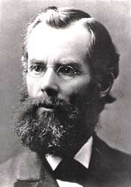
John Nevins Andrews
What learning institution is named after John Andrews?
………………………………………………………………………………………………….

In 1874 Andrews became the first official Seventh-day Adventist
Missionary. Which continent was he sent to? ……………………………………
Specifically which country? ………………………………………………………………

John Andrews wrote a book about the Sabbath. What was the title of that book?
………………………………………………………………………………………………………………............

What was the most prominent position that John Andrews held in the Seventh-
day Adventist Church? ………………………………………………………………………………………
When did he hold that position? ……………………………………………………………………….

What periodical in the French language did Andrews help start?
………………………………………………………………………………………………………………………….

