Exercise 1(Pre – Activity research)

Disability Access Symbols
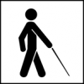
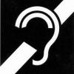
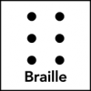

Exercise 2

What do you know about disability?
- Is Disability an illness? Yes, no, do not know? [ ]
- What are the issue for people with an impairment or disability (Give one)?

[ ]
- Scenario: You walk to a door and the door is locked you feel disabled because you cannot get in without the key! 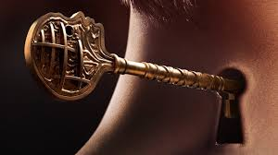
- In terms of disability what can be the key to unlock their disability? Give one [ ]
- The lock door is like stairs to a person who using a wheel chair as shown in the first slide, noise of many people talking in a room can be a locked door to someone with a hearing impairment, and obstacle course could be a lock door to someone with a visual impairment.

Exercise 3

A brief look at the Pathfinder Law. What does it ask of us?

How can we keep the morning watch?

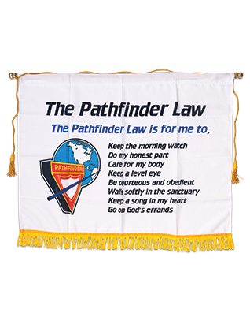
- Planning the Party/Social.

Zoom Planning meeting agenda 14/03/2021:

Zoom Meeting Agenda:
- Date and venue (access and welcome)
- Numbers
- 8 Pathfinder Clubs (budget)
- 150 attendees, visitors and entrance fee
- Event food and refreshments (Menu, Diet and Allergies)
- DJ and Host/Comparer
- Start and finish time
- Risk Assessment and Health and Safety requirements
- Discuss in groups 2 -3 activities, games, pathfinder expo, Inclusive and Engaging. That could be provided or organised for the day?
- Five - eight breakout rooms

VOYGER ZOOM MEETING NOTES/MINUETES
Venue | Menu | Allergies
Numbers of Pathfinders from each club | Numbers of Counsellors and others from each club | Venue Set-up 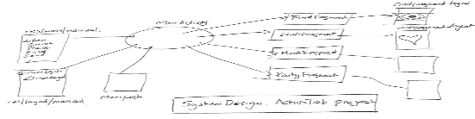
Numbers of people with a disability or impairment | Activities for all | Health and Safety and Risk Assessments
 | - Pin the tail on the donkey (Rules)  - Pairs  - Musical Statues  - Expo  - Others | Attendees  B Venue  Checked by who and when?  State risk level (1-10) [ ]
Access | Thing to be done and by who? | By which Club
List the assess issues: | - Venue booking  - Menu  - Food purchases  - Risk Assessments  - Catering  - Activity lead  - Music (DJ, Performer etc.) | e.g. Peterborough Central – (Director/Pathfinders/Counsellors)

List the activities -: Add your 3 activity ideas?

Each Pathfinder will create or suggest an activity which the Voyagers will vote on and choose the three most popular to add to their list.
Type Activities and Name/Title | Educational and Spiritual | Lead Person/Club
Pin the tail on the Donkey
Rules:

Pair Up?
Rules:

Pathfinder Expo  What does the Acronym stand for? | N  E  W  S  T  A  R  T
Musical Statues?
Rules:

Exercise 4

Design your own or complete this Menu for your social. (Club activity)
Foods | Numbers/Servings | Allergies

