Universe

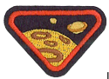
Requirements:
1.Read Bible verses about God creating the universe and heaven.
Read Genesis 1 and Revelations 21-22
2.Discuss what Heaven will be like and draw a picture depicting your view of Heaven.
___________________________________________________________________________
___________________________________________________________________________
___________________________________________________________________________
___________________________________________________________________________
___________________________________________________________________________

3.Find Bible verses about the universe, stars, moon, planets, and/or sun. (Print off space game in question 7b for bible verse suggestions.
___________________________________________________________________________
___________________________________________________________________________
___________________________________________________________________________
4.Make a craft of our solar system.
Solar System DIY Mobile https://www.education.com/worksheet/article/solar-system-mobile/
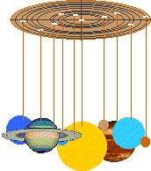
Name the 8 planets.
My 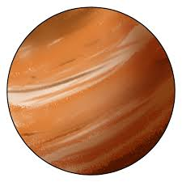 M________________________________
Very 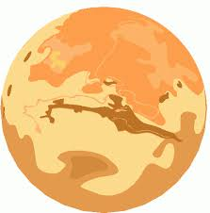 V__________________________________
Excited 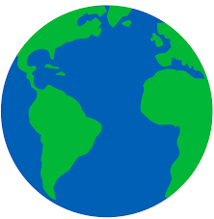 E________________________________
Mother 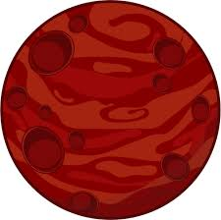 M__________________________________
Just 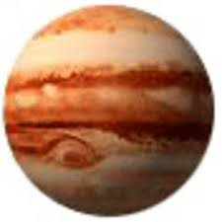 J________________________________
Served 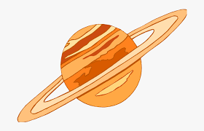 S__________________________________
Us 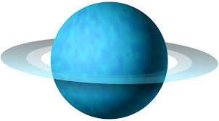 U________________________________
Nachos 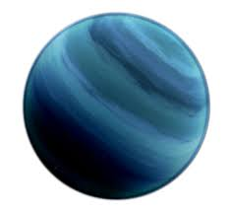 N__________________________________

5.What is the universe?
The Universe is e______ _____________ God c______________. This is everything we can t________________, feel, sense, measure or detect. It includes l___________ things, p___________, s___________, g______________, dust clouds, l____________, and even t_________________.
stars planets everything galaxies touch
created living light time
6.What is the Milky Way? 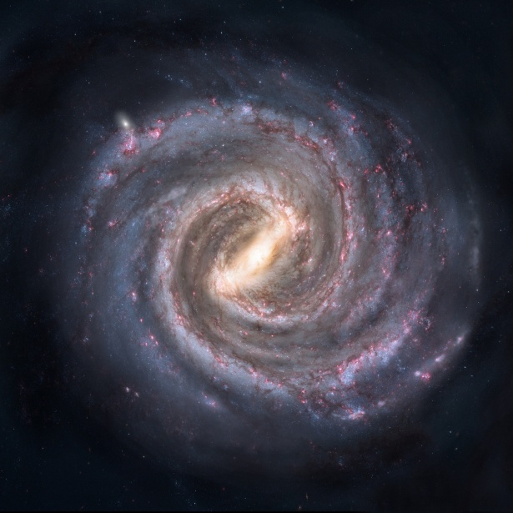
The M___________ W__________ is the name given to the g____________ our
S_____________ S_________________ is located in.
It is called this because of t________________________________________________ when viewed from E.
A galaxy is a large group of stars bound together by gravity.
the way it looks Milky Way Earth Solar System galaxy

7.Play a space game suggestions:
a. Meteor water balloon fight
b. Print off cards in below link and play the memory game.
https://www.dropbox.com/s/c4ubp96bk79leou/memory%20game.pdf?dl=0
c. Make a rocket with paper bag with a balloon inside, let go of the balloon and watch as you ‘launch’ your rocket into space.

For further resources please follow the below link
https://www.snecyouth.com/wp-content/uploads/2020/04/parentinformationadventureruniversehonors.zip
Alternative craft –
https://print-cut-paste-craft.com/free-printable-solar-system-model-for-kids/

Extra resource
https://byjus.com/physics/celestial-bodies/
- Stars
Stars are giant balls of hot gases that can produce their own light. Stars give out energy by converting Hydrogen gas into Helium in their cores. Stars are gigantic in size and have immense gravitational attraction. The sun is a medium-sized star that gives us energy and makes life possible on earth.
- Planets
Planets are large (almost) spherical objects that revolve around the sun. Planets move in fixed orbits around the sun. There are 8 planets in our solar system. Planets may be made of rocks, metals and gases like hydrogen, nitrogen and methane. The earth is also a planet and is the only known place in the universe which supports life. Planets that revolve around other stars are called exoplanets.
- Satellites
Satellites are objects that revolve around planets. They form the essential part of the celestial bodies. These may be of natural origin or sent by humans. The moon is a natural satellite of the earth and revolves around it because it is bound by the Earth’s gravitational pull. Man has also placed artificial or man-made satellites around the earth and other planets to study them and for communication purposes.
- Comets
These are small chunks of ice and rock that come from the outer edge of the solar system. When its orbit brings it closer to the sun, the ice on them vaporizes creating a beautiful tail behind them.
- Asteroids
These are small irregularly shaped rocks made up of metal or minerals that orbit the sun. Most of them are found between Mars and Jupiter in an area known as the asteroid belt.
- Meteors and meteorites
These are objects from space that enter our atmosphere as they are pulled by the earth’s gravity. Meteors usually are small and burn up in the atmosphere as they enter the earth. This creates streaks in the sky as though a star has fallen. They are commonly called shooting stars. If a meteor is large enough it can reach the ground and create a crater. Such objects are called meteorites.
- Galaxies
Galaxies are large groups of stars held together by gravity. The sun and the solar system is part of a galaxy known as the Milky Way. Other galaxies are usually so far away that they look like stars in the night sky. The Andromeda galaxy and the Large Magellanic Cloud are galaxies that can be seen with the naked eye on a clear night.
The next time you go out to wonder at the night sky, try to identify these objects. If you can get a star chart, use it to find the different celestial objects mentioned in the night sky.

