Read Genesis 1: 1 and Colossians 1: 16 -17
What do these verses mean to you?
……………………………………………………………………………………………………………………………………
……………………………………………………………………………………………………………………………………
Icebreaker: Elephant Toothpaste demonstration

DEFINITIONS
- The diagram below show the conventional model of an atom.
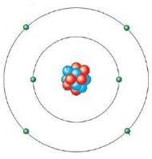

Label the sub-atomic particles; protons, electrons and neutron in the diagram, stating their charge and relative mass.
Complete the table below:
Sub-atomic particle | Relative mass | Relative charge | Location
Proton | 1
Neutron | 1
Electron | 0.005

- We define an atom as the smallest particle of an element. The diagrams below show the models of elements, molecules and compounds.

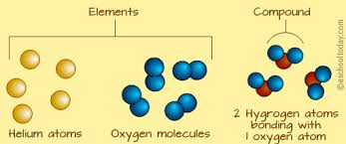
Use the diagram above to deduce definitions of the following terms:
- An element is ……………………………………………………………………………………………………
- A compound is …………………………………………………………………………………………………
………………………………………………………………………………………………………………………..
- A molecule is ……………………………………………………………………………………………………
The diagram below shows a Periodic Table of elements.
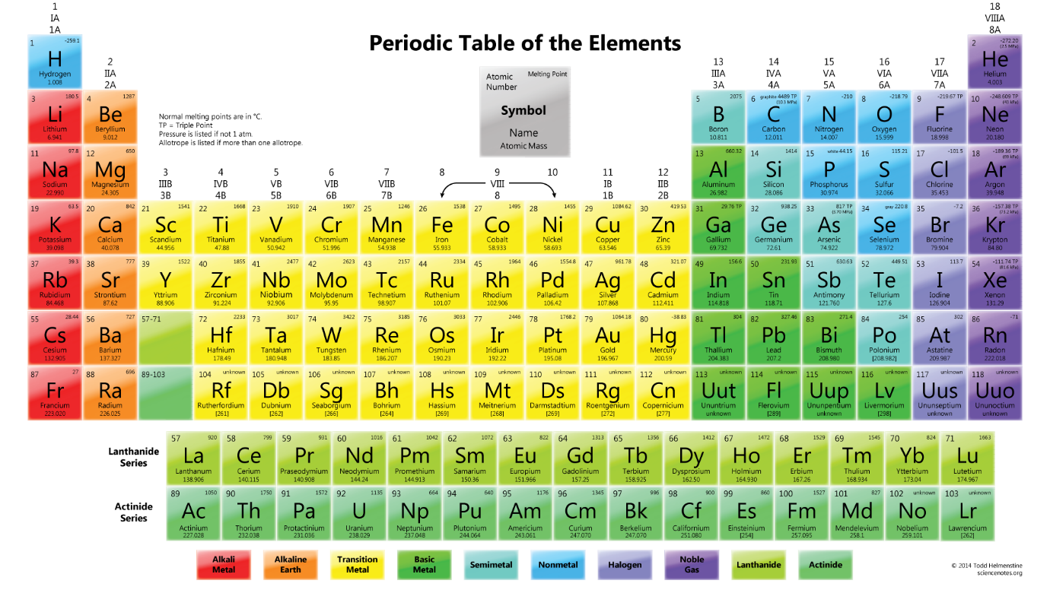
d) Use The Periodic Table to write a statement describing what it is. ……………………………………………………………………………………………………………………………………………………………………………………………………………………………………………………
e) State the names of the elements with following chemical symbols:
Na ………………….. Ca ……………………. C ……………………. Co ……………………
K …………………… Ag …………………….. Au …………………. O …………………….
- The diagram below shows a model for combustion reaction of methane gas.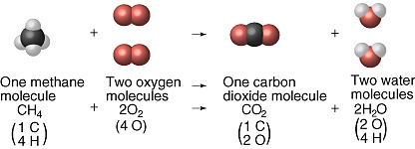
Use the combustion diagram above to define the term combustion
…………………………………………………………………………………………………………………………………………………………………………………………………………………………………………………………
- Use the following diagram to define the term solution.
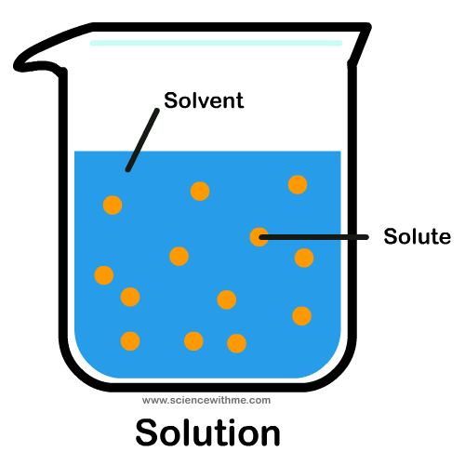
A solution is ……………………………………………………………………………………………………
…………………………………………………………………………………………………………………………
- The diagram below shows a pH Scale.
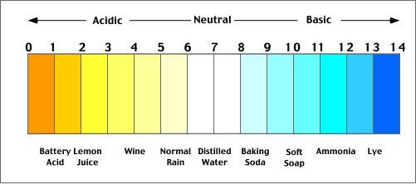
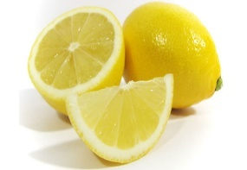
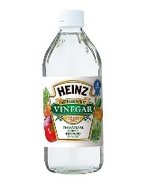
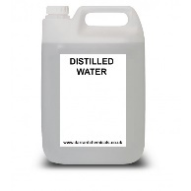
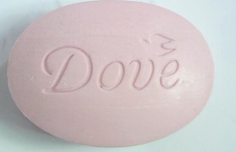
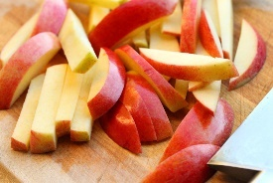

Sort the above items as either acidic, basic or neutral using the pH scale on page 3.
Dove soap:……………….. Apple: …………………. Mr Muscle: …………………..Vinegar:……………….
Lemon:……………….. Windex with ammonia: ……………………Distilled water:…………………….
- An acid is a corrosive substance with a pH …………………………. Acidity is caused by a high concentration hydrogen ions
- A base is a corrosive substance with a pH……………………… which has a high concentration of hydroxyl ions
- A salt is substance formed when an acid reacts with a base, carbonate or metal. The name of the salt depends on the metal in the base and the acid used. For example, salts made using hydrochloric acid are called chlorides. Salts of nitric acid are called nitrates. Salts of sulfuric acid are called sulfates
Complete the following word equations for the formation of salts the first one is done for you:
- Copper oxide + sulfuric acid ⟶ copper sulfate + water
- Sodium hydroxide + hydrochloric acid ⟶ ………………………………. + water
- Magnesium oxide + nitric acid ⟶ …………………………………… + water
- Sodium carbonate + sulfuric acid ⟶ ………………………….+ Carbon + water
Dioxide
Experimental Techniques for the Separating of Mixtures
- Filtration
Study the diagram below and come up with a definition for the term filtration.
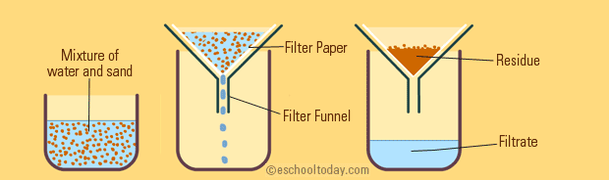

Filtration is a method for separating a mixture of a ………………….. and a ……………

- Distillation
The diagram below shows distillation apparatus set up. Use the diagram to come up with a definition of distillation.
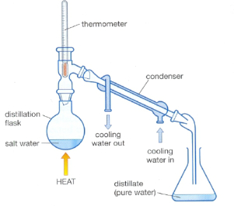
Distillation is method of a separating water soluble substance by ……………………………… and ……………………………… the solvent (distillate)
- Fractional distillation
The diagram below shows fractional distillation of crude oil. Use the diagram to come up with a definition of fractional distillation.
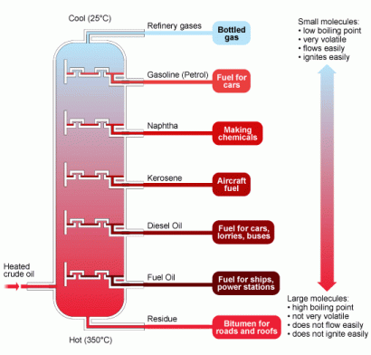
Fraction distillation is method of separating a mixture of ……………………….. on the basis of their …………………………
…………………………

- Fire Extinguishers
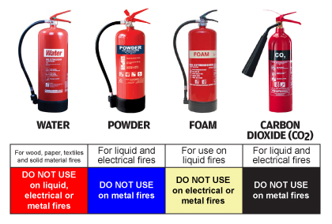
The diagrams below show for differed types of fire extinguishers and the type of fires they extinguish.

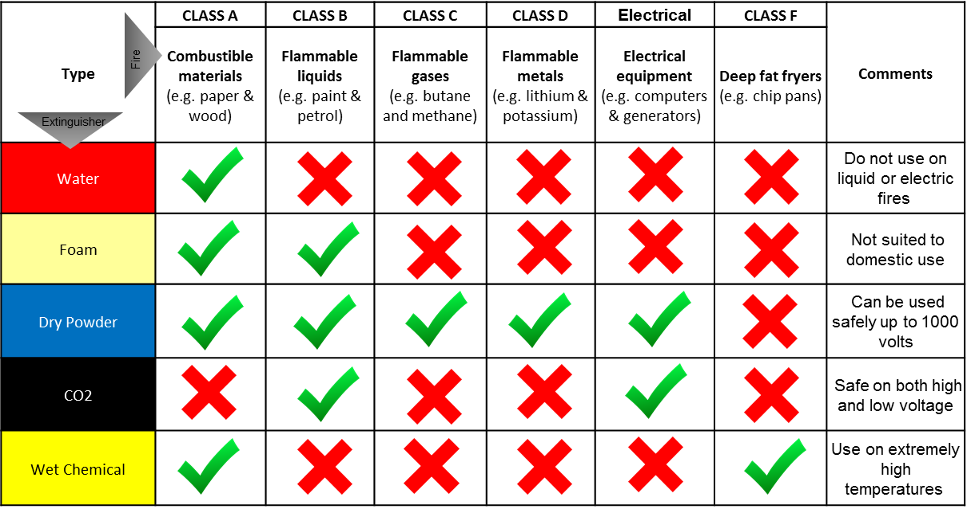
Name a gas which causes things to burn (supports combustion) ………………………………….
…………………………………….
The table below shows the densities of a few gases:
Oxygen: 1.429 g/L; Hydrogen: 0.08988 g/L; Carbon dioxide: 1.96 g/L; Nitrogen: 1.251 g/L
A heavier gas will displace a lighter gas. State the gas that is denser than oxygen. …………………………………………………
Describe, in the space below, how a CO₂ Fire Extinguisher works.
…………………………………………………………………………………………………………………………………………………………………………………………………………………………………………………………………………………………………………………………………………………………………………………………………………………………………………………………………………………………………………………………………………………………………………………………………………………………………………………………………………………………
- Carbon monoxide
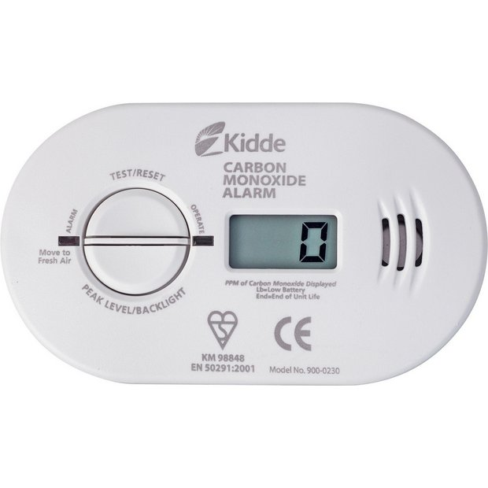
In pairs use the resource sheet on carbon monoxide to answer the following questions:
- Name two common sources of carbon monoxide. ………………………………………………………………………………
………………………………………………………………………………
- Explain why carbon monoxide is dangerous. …………………………………………………………………………………………………………………………………………………………………………………………………………………………………………………………………………………………………………………………………………………………………………………………………………………………………………………………………………………………………………………………………………………………………………………………………………
- States of Matter
Use the Physical States resource find the states of matter, illustrate with diagrams and write short notes about them in the space below.

- Experimental activities and explanation of chemical action.
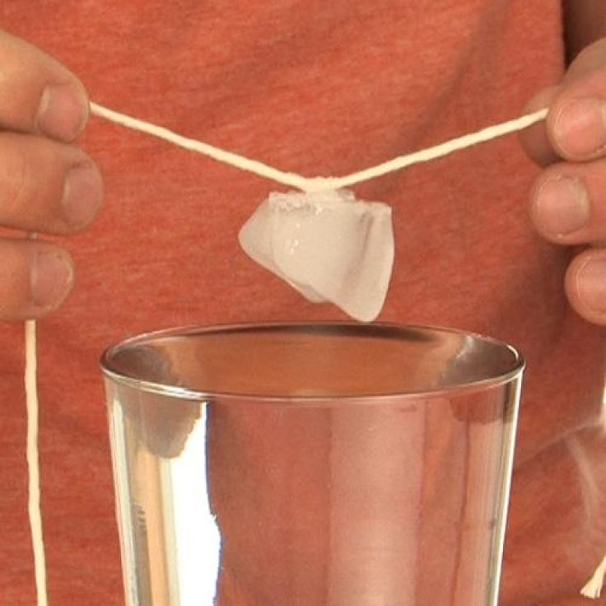
- Picking an ice cube with a string
Observe the experiment and use the resources for this experiment to word an explanation of what is happening and how that same principle has been used in our day to day lives.

Explanation:
…………………………………………………………………………………………………………………………………………………………………………………………………………………………………………………………………………………………………………………………………………………………………………………………………………………………………………………………………………………………………………………………………………………………………………………………………………………………………………………………………………………………………………………………………………………………………………………………………………………………………………………………………………………………………………………………………………………………………………………………………………………………………………………………………………………………………………………………………………………………………………………………………………………………………………………………………………………………………………………………………………………………………………………………………………………………………………………………………………………………………………………………
Application of principle
………………………………………………………………………………………………………………………………………………………………………………………………………………………………………………………………………………………………………………………………………………………………………………………………………………………………………………………………………………………………………………………………………………………………………………………………………………………………………………………………………………………………………………………………………………………………………………………………………………………………

- Three parts of a candle flame
Label the parts of a candle flame showing which on hottest and the least hot.

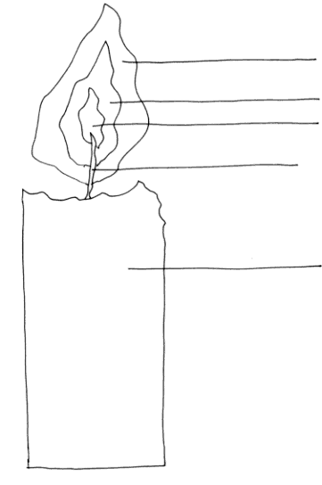
- Surface tension and surfactants experiment
Observe the experiment and use the provided resources to explain your observations.
Explanation:
……………………………………………………………………………………………………………………………………………………………………………………………………………………………………………………………………………………………………………………………………………………………………………………………………………………………………………………………………………………………………………………………………………………………………………………………………………………………………………………………………………………………………………………………………………………………………………………………………………………………………………………………………………………………………………………………………………………………………………………………………………………………………………………………………………………………………………………………………………………………………………………………………………………………………………………………………………………………………………………………………………………………………………………………………………………………………………………………...
- A fresh egg and density of medium
Observe the experiment and use the provided resources to explain your observations
Observations:
..................................................................................................................................................................................................................................................................................................................................
Explanation:
………………………………………………………………………………………………………………………………………………………………………………………………………………………………………………………………………………………………………………………………………………………………………………………………………………………………………………………………………………………………………………………………………………………………………………………………………………………………………………………………………………………………………………………………
- Flame tests.
The flame colour observe is due to the metal in the compound. Record your observations in the table below:

Compound | Flame colour
Sodium chloride
Potassium chloride
Copper sulfate
Boric acid

~END OF WORKSHEET~

