Μψ Χηυρχη

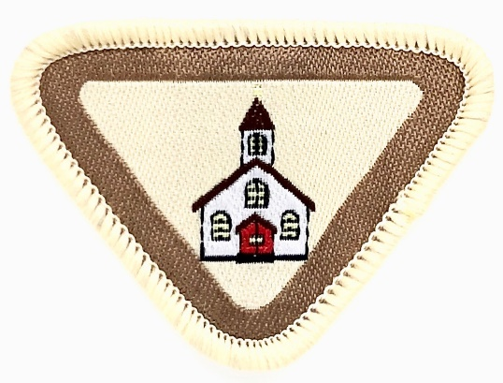
Name: ____________________ Class __________
Date ____________

Purpose of My Church Award:
To understand the many roles of church members in the function of the church.
Resources:
The SDA Church Manual
The Nominating Committee’s Report
The Pastor

- Understand the meaning and memorize I Corinthians 3:16 and learn the song “Lord, Prepare Me to Be a Sanctuary.”
https://youtu.be/q9eIo-JRF1I (Link for the song)
https://youtu.be/YgySsI2FX10 (Link for instrumental with lyrics)
______________________________________________________________________________________________________________________________________________________________________________________________________________________________________________________________________________________________________________________________________________________________

- Know the name of your church, and write the address. As a club, draw a mural with the church in the centre and include each Adventurer’s house in relation to our church, naming all roads and streets as a map to the church

CHURCH NAME:_________________________________________________________________

ADDRESS:____________________________________________________________________________________________________________________________________________________

- Who is your pastor and what is his/her responsibility?

Ask the following questions. INTERVIEW WITH PASTOR
a. Why did you decide to become a Pastor?
---------------------------------------------------------------------------------------------------------------------------------------------------------------------------------------------------------------------------------------------------------------------------------------------------------------------------
b. At what age did you decide to become a Pastor?
---------------------------------------------------------------------------------------------------------
c. Was there something that happened in your life that caused you to want to be a pastor?
---------------------------------------------------------------------------------------------------------
---------------------------------------------------------------------------------------------------------------------------------------------------------------------------------------------------------------------------------------------------------------------------------------------------------------------------
d. Can I be a pastor, if God calls me?
---------------------------------------------------------------------------------------------------------
---------------------------------------------------------------------------------------------------------------------------------------------------------------------------------------------------------------------------------------------------------------------------------------------------------------------------
e. How can I prepare for a life to serve God?
---------------------------------------------------------------------------------------------------------------------------------------------------------------------------------------------------------------------------------------------------------------------------------------------------------------------------
f. How can I be a minister right now?
---------------------------------------------------------------------------------------------------------------------------------------------------------------------------------------------------------------------------------------------------------------------------------------------------------------------------

- Draw the floor plan of your church. If your church has the following, label them on your map.
a. Sanctuary
b. Church Office
c. Your Sabbath School Room
d. Fellowship Hall
e. Restrooms
f. Adventurer Room
g. Community Service Room

- What is a church board and what is its function?

- Name 10 members on the church board. What position(s) do they hold.

1. PASTOR:____________
2. HEAD DEACON:__________
3.HEAD DEACONESS:___________
4.TREASURER:___________
5. CLERK:___________
6. PATHFINDER:____________
7.YOUTH MINISTRY LEADER:_________
8. SABBATH SCHOOL LEADER:____________
9. HEALTH MINISTRY LEADER:________________
10. WOMEN MINISTRY LEADER:______________

- Explain how you can help God in your church every week starting this week?
------------------------------------------------------------------------------------------------------------------------------------------------------------------------------------------------------------------------------------------------------------------------------------------------------------------------------------------------------------------------------------------------------------------------------------------------------------------------------------------------------------------------------------------------------------------------------------------------------------------------------------------------------

REQUIREMENTS:

1. Understand the meaning and memorize I Corinthians 3:16 and learn the song “Lord, Prepare Me to Be a Sanctuary.”
2. Know the name of your church, and write the address. As a club, draw a mural with the church in the center and include each Adventurer’s house in relation to your church, naming all roads and streets as a map to the church.
3. Who is your pastor and what is his/her responsibility? Ask the following questions.
a. Why did you decide to become a pastor?
b. At what age did you decide to become a pastor?
c. Was there something that happened in your life that caused you to want to be a pastor?
d. Can I be a pastor, if God calls me?
e. How can I prepare for a life to serve God?
f. How can I be a minister right now?
4. Draw the floor plan of your church. If your church has the following, label them on your map.
a. Sanctuary
b. Church Office
c. Your Sabbath School Room
d. Fellowship Hall
e. Restrooms
f. Adventurer Room
g. Community Service Room
5. What is a church board and what is its function?
6. Name 10 members on the church board. What position(s) do they hold?
7. Explain how you can help God in your church every week starting this week?

