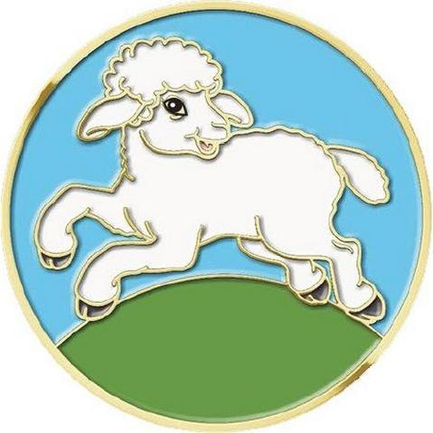 My World: Creation Award 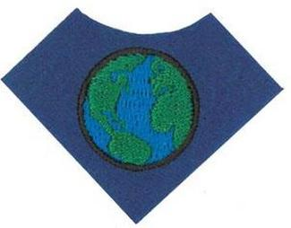

Little Lamb

1. Sing a song about creation.

<https://youtu.be/3-9_lOeaGhs>

The name of the song I sang:

--------------------------------------------------------------------------------------------

1. Listen to a story about creation.

<https://youtu.be/E_9dFR4Gbn4>

Did you like the story?

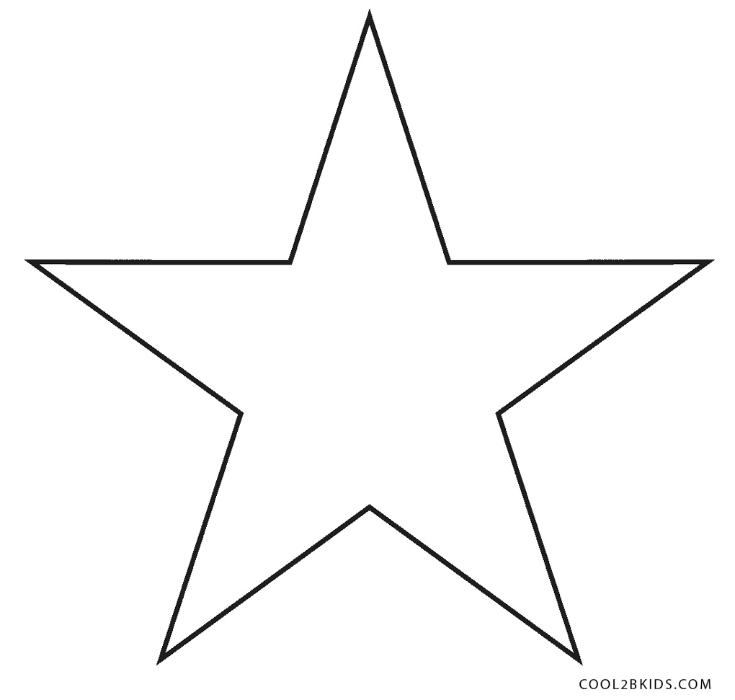    

1. Say three things you have learned about creation. Circle/tick to choose your answer (3 only).

God is powerful, beautiful designs & patterns, lovely Colours,

animals, birds, beautiful flowers, trees and plants, sun, moon and

stars, light, the seas waves, mountains, Sabbath day.

1. Make a craft about creation: Days of Creation Ball (See instruction sheet)
2. Complete an activity about creation: insert photos for evidence.

Activity: The Land and Seas centre (see instruction sheet).